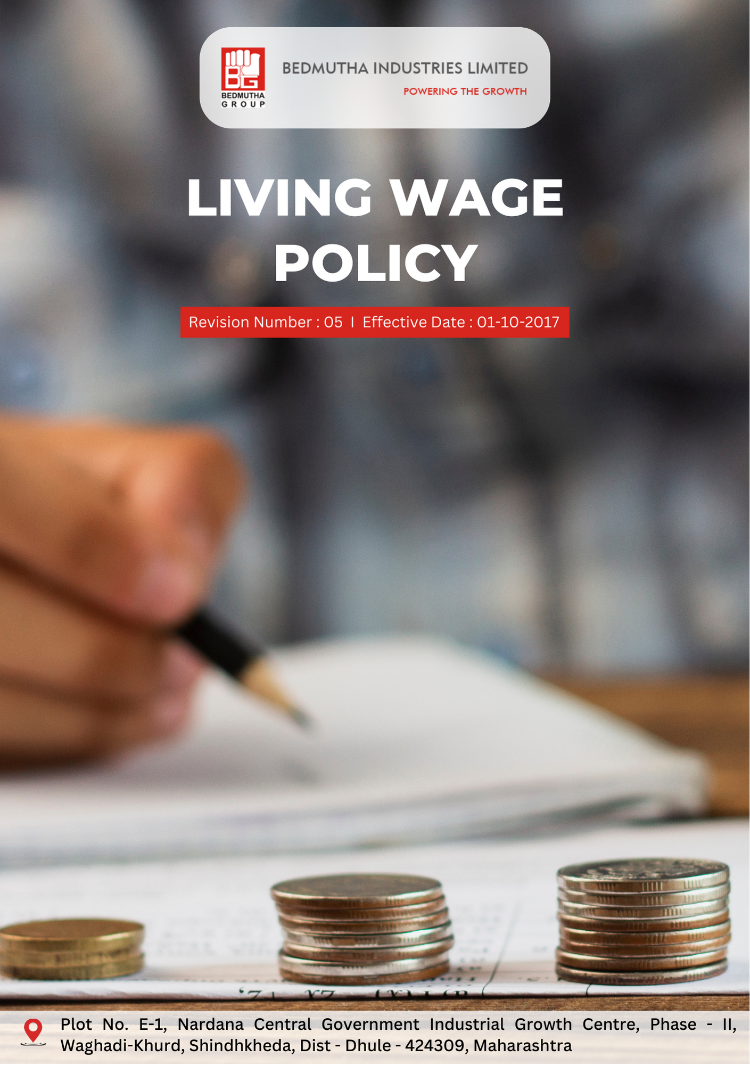

INDEX

1. Commitment to Living Wage 3
2. Promoting Fair Compensation and Equity 3
3. Scope 3
4. Responsibilities and Expectations 4
5. Specific Living Wage Commitments: 4
6. Roles and Responsibilities: Governance Introduction 5
7. Internal and External Reporting Mechanisms 6
8. Covered SDGs 6
9. Review Mechanism 6
10. Employee Acknowledgement Form: Living Wage Policy : 7

Commitment to Living Wage
Bedmutha Industries Ltd remains committed to ensuring fair, equitable, and competitive compensation for all employees, regardless of gender, role, or geographic location. The Living Wage Policy reflects our dedication to fostering an inclusive and fair workplace by addressing wage disparities and promoting equal opportunities across our organization. This policy includes a firm commitment to paying a living wage to all employees, with clear targets, public transparency, and mechanisms to ensure sustained adherence to living wage standards.

Promoting Fair Compensation and Equity
At Bedmutha Industries Ltd, we are committed to fostering a workplace that values fairness, inclusion, and transparency in compensation practices. This commitment ensures all employees receive equitable pay for their contributions, aligned with our values and ethical standards.

Our policy prioritizes living wages, competitive salary structures, and unbiased compensation systems that reflect employee skills, experience, and responsibilities. This includes proactive measures to address pay gaps, periodic wage reviews, and alignment with global standards for fair compensation.

We set quantitative targets, develop robust systems, and allocate the necessary resources to ensure consistent adherence to this policy. Through collaboration, innovation, and transparency, Bedmutha Industries extends its commitment to Living wage across the entire organizational and operational framework.

Scope
The Living Wage Policy applies to all employees, contractors, and consultants of Bedmutha Industries Ltd across all operations, departments, and facilities:

Bedmutha Industries Ltd
Address: Plot No. E-1, Nardana Central Government Industrial Growth Centre, Phase -
II, Waghadi-Khurd, Shindhkheda, Dist - Dhule - 424309, Maharashtra.
http://www.bedmutha.com/

Responsibilities and Expectations
- Commitment to Fair Wage Practices
Bedmutha Industries Ltd upholds its dedication to Living Wage by implementing and enforcing standards that promote fair and transparent compensation practices for all employees. The company ensures alignment with global best practices and labor laws through the following actions:
- Conducting regular wage assessments to ensure all employees are paid at or above the living wage threshold, reflecting local economic conditions and industry benchmarks.
- Providing training programs for HR personnel and managers on fair compensation structures, living wage standards, and unbiased pay practices.
- Engaging third-party auditors to verify compliance with Living Wage standards and address any discrepancies proactively.
- Establishing mechanisms for employees to raise concerns or grievances regarding wage disparities anonymously, ensuring confidentiality and non-retaliation.
- Promoting transparency by publishing annual reports on wage practices and progress toward achieving quantitative targets for living wages.
- Reviewing compensation policies regularly to ensure continuous alignment with industry standards and evolving economic conditions.
- Collaborating with unions and worker representatives to ensure fair wage practices and foster open dialogue about compensation-related concerns.
- Encouraging a culture of fairness by linking performance management and rewards systems to clearly defined and equitable criteria.

Specific Living Wage Commitments:
- This policy establishes 2022 as the baseline year for measuring progress and achievements in Living Wage initiatives.

- Living Wage Targets:
- By 2026, Bedmutha Industries Ltd will ensure that 100% of its workforce is paid above the living wage benchmark for their respective locations.
- The company has publicly announced its quantitative target of achieving living wage compliance by the end of 2026 and commits to regular updates on its progress through annual reports.
- A continuous commitment to maintaining living wage compliance will be enforced, with yearly reviews to adjust benchmarks in line with inflation, cost of living, and market changes.

- Equal Pay Initiatives:
- Bedmutha plans to achieve 100% compliance with industry standards for gender pay parity by 2026.
- The company targets annual disclosure of pay equity audit findings to foster transparency and accountability.

- Supplier and Partner Alignment:
- By 2026, all suppliers and contractors will comply with living wage principles, verified through independent audits.
- Bedmutha aims to monitor and evaluate supplier adherence to living wage practices annually.

Roles and Responsibilities: Governance Introduction
The governance structure at Bedmutha Industries Ltd for the Living Wage Policy ensures clear allocation of responsibilities, promoting accountability, effective implementation, and continuous progress toward our Living Wage objectives:

- The Board of Directors ensures the overall implementation of the Living Wage Policy, holding senior management accountable for achieving wage equity and living wage goals.

- The HR Department conducts annual wage audits, oversees corrective actions for disparities, and ensures compliance with living wage standards.

- The Compliance and Audit Team ensures adherence to Living Wage laws, verifies living wage adherence, and manages third-party audits for transparency.

- Managers are responsible for ensuring fair pay within their teams and addressing wage-related concerns promptly.

- Employees are encouraged to participate in Living Wage initiatives, report discrepancies, and engage in discussions about pay practices.

- Suppliers and Contractors are required to comply with Bedmutha’s Living Wage principles and undergo periodic assessments to verify adherence.

Internal and External Reporting Mechanisms
- Internal Reporting: Bedmutha provides confidential channels, including a Living Wage hotline and HR grievance portal, for employees to report wage-related concerns. All complaints are reviewed by the HR Department and escalated to senior management if necessary.

- External Reporting: The company publishes an annual Living Wage Report, outlining progress on living wages, pay audits, and corrective actions. Bedmutha engages third-party auditors to validate its commitment to Living Wage and compliance with industry standards.

Covered SDGs
 |  | 

Review Mechanism
- Bedmutha conducts an annual review of the Living Wage Policy to evaluate its effectiveness, including living wage targets and alignment with evolving labor laws, wage benchmarks, and stakeholder expectations.

- The HR Department annually reviews the policy process in collaboration with independent auditors and employee representatives. Updates are presented to the Board of Directors for approval and subsequent implementation.

(Signature)
Approved By:
Last Review Date: 01-01-2025 Next Review Date: 01-01-2026

Employee Acknowledgement Form: Living Wage Policy :

I, acknowledge that I have received, read, and understood the Living Wage Policy of Bedmutha Industries Ltd. I recognize the company’s commitment to ensuring fair and equitable wages, including its publicly announced targets for achieving and maintaining a living wage for all employees.
I agree to adhere to the principles of this policy and participate in relevant training and discussions to promote Living Wage within the organization. By signing below, I confirm my understanding and commitment to fostering a workplace built on fairness, transparency, and inclusivity.

Employee Name: ______________________
Date: _______________
Employee Signature: ____________________

